**ASSIGNMENT 4**

|  |  |
| --- | --- |
| **Date** | 2 Nov 22 |
| **Team ID** | PNT2022TM ID23535 |
| **Project Name** | Gas Leakage Monitoring and Alerting System for Industries |

Write code and connections in wokwi for ultrasonic sensor.

Whenever distance is less than 100 ems send "alert" to ibm cloud and display in device recent events.

Upload document with wokwi share link and images of ibm cloud **CODE:**

|  |  |
| --- | --- |
| #include <WiFi.h>  #include <PubSubClient.h> i iCliert  #define .. "nhpwjc"  #define - "NodeMCU"  #define :v1 "USE YOUR ID" #define HE "USE YOUR TOKEN"  #define )('f-, 0.034 char ver LI  ".messaging. internetofthings.ibmcloud. com"  "iot-2/evt/Data/fmt/json" char 2/cmd/home/fmt/String" char ,rod ] char | char 1b L Lsh op .c. [  "iot-  "use-tokenauth" |
| char Lie·n.Id ] **"d: II II• II** :VICE: rr  c.l it *vt=-,·,* 1883, wi iClit  canst int rispin 5; canst int 'lapin 18;  String String 1+ long    float ic;t.    void  setup    **Serial** begin 115200  pinMode OUTPUT | **II• II** :::::>; void Jb •• c,h;:)dtd(,; |

|  |
| --- |
| pinMode hopir INPUT wi f..C on nee t, , ,  .');  void loop ◄ publisrDat (), delay 500*J;* if !cl iN loop ) { mqt tConnec. t ( , , •  void  **Serial** print "Connecting to" **Serial** print "Wifi"  begin "Wokwi-GUEST" 6 while ) !  delay 500,,  **Serial** print"."  **Serial** print "WiFi connected, IP address: " **Serial** println  void t tC.unnu t 1) if  **Serial** print "Reconnecting MQTT client to" **Serial** println while  **Serial** print delay 500,,  } rn ..tMdndged'1eviu,( **Serial** println } } void ·itManagPdDt'Vice' l if  // Serial. println(client. subscribe(topic)); **Serial** println "subscribe to cmd  **OK"** else  **Serial** println "subscribe to cmd FAILED" } void digitalWrite 'ig,.>i LOW digitalWrite ·igp HIGH |
| delayMicroseconds 10  digitalWrite LOW pulsein HIGH  2 if 100  String ylot.c.. "{\"Alert distance\":"  **II }II**  **Serial** print "\n"  **Serial** print "Sending payload: " **Serial** println 1yl >dd  if char - r  **Serial** println "Publish OK" else  **Serial** println "Publish FAILED" |

**CONNECTIONS:**

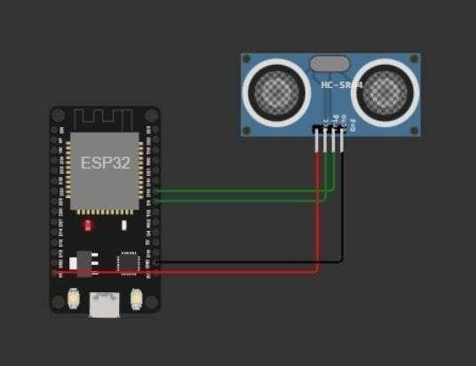

**OUTPUT:**

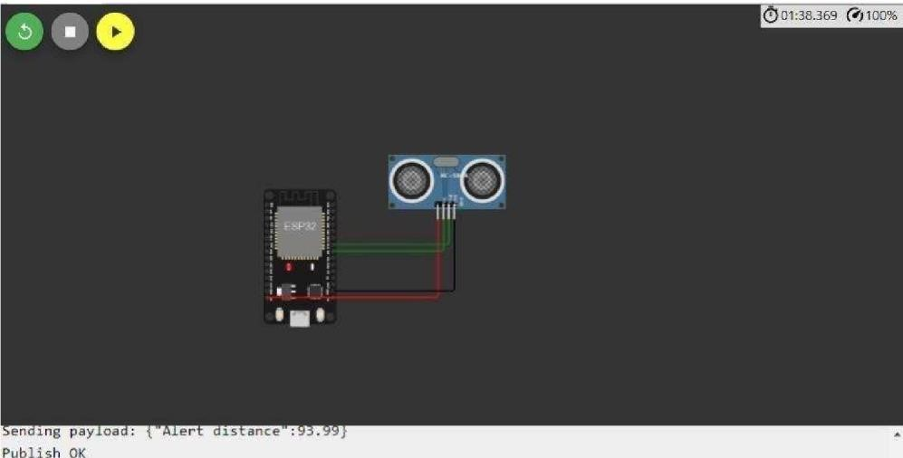

Sen.ding payload: {"Alert distance":93.96} Publish OK

Sen.ding payload: {"Alert distance":93.96}

Publish OK

Sending pay load: {"Alert distance":93.96}

Publish OK

Sending pay load: {"Alert distance":93.96} Publish OK

Sending pay load: {"Alert distance":93.96}

Publi.sh OK

II**m**

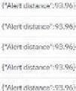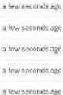

I

I

I

I

""

'

...

...

ti

\

¢

i

:

-

v

r

...

.(.

.al

ac

-

,,,c,::;.•fl.ll

n.w,.•I)(."

\

:

1

,

100

J

J:

t,,,.r

I)(:

1111.

-

,

·

,

O

-

itcho.'d

:.(:

Oil

j,oO!j(li'fOf •

ll

rnio,1,

-

..

Tng.

-

io:1..,.,..,,,.

-

p,anM<l

b)'

smgh>

\

Dd

ic.r.o..,.

.......

,_,,.b',1,

-

g

J



# WOKWILINK-

**https://wokwi.com/projects/346405970317935188**